CSE420
Samuel Marrujo
Professor Yu
Lab 05

Canvas
In this part of the lab, it was a modification of the original canvas program. After some modifications to the program, and adding in the functions asked for, the result was the following reproduction of the figure. Because of this change to the functions and the addition of the figure, I believe I was able to accomplish this task successfully, since there were no errors and the display window was changed. Here are my results for this program:

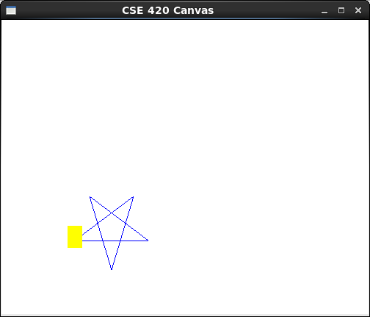

//demo_canvas.cpp
#include "canvas.h"

Canvas cvs(500, 400, "CSE 420 Canvas"); //global canvas object

void display()
{
cvs.setViewport(0, 200, 0, 200);
cvs.getViewport();
cvs.clearScreen(); //clear screen
cvs.setColor ( 0.0, 0.0, 1.0 );
cvs.setBackgroundColor( 1,1,1 );
cvs.moveTo( 0, 0.0 ); //draw line
cvs.lineTo( 10, 0.0 );
cvs.lineTo( 2, 6.0);
cvs.lineTo( 5, -4.0);
cvs.lineTo( 8, 6.0);
cvs.lineTo( 0, 0.0 );
cvs.getWindowAspectRatio();
cvs.setColor ( 1.0, 1.0, 0.0 );
cvs.setViewport(300, 200, 0, 200);
RealRect box( -1.0, 1.0, -1.0, 2.0 ); //construct a box
box.draw(); //draw box
glFlush();
}
Curves

In this part of the lab, we were to reproduce the curves of a hyperbola, an ellipse, and a spiral. I was able to successfully complete this as shown below:

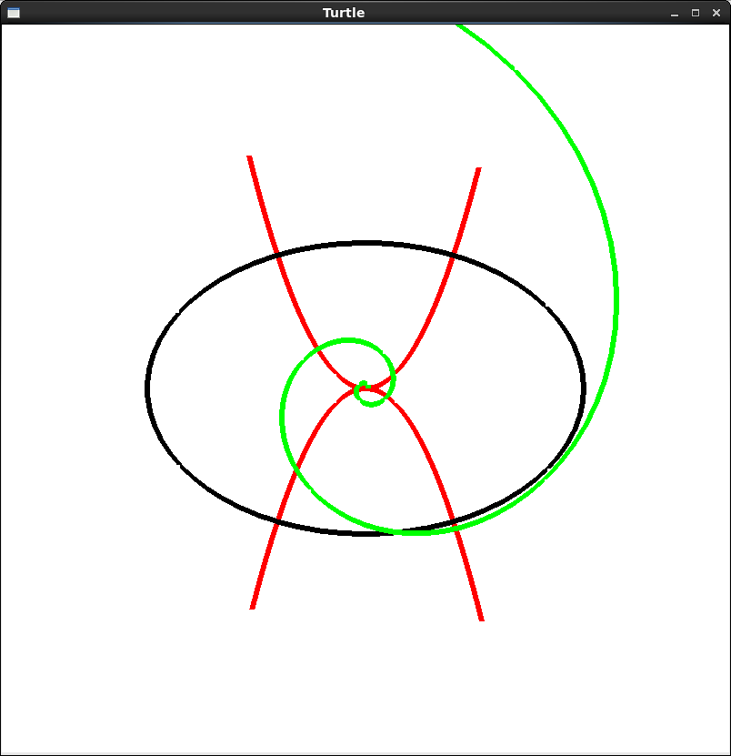
#include "canvas.h"

Canvas cvs ( 800, 800, "Turtle" );

void parabola()
{
cvs.setWindow ( -200, 200, -200, 200 );
double a = 8, t, x, y;

t = -4;
y = a * t * t;
x = 2 * a * t;
cvs.moveTo ( x, y );

for ( t = -4; t <= 4; t += 0.1 ) {
y = a * t * t;
x = 2 * a * t;
cvs.lineTo ( x, y );
}
}

void parabola_two()
{
cvs.setWindow ( -200, 200, -200, 200 );
double a = -8, t, x, y;

t = -4;
y = a * t * t;
x = 2 * a * t;
cvs.moveTo ( x, y );

for ( t = -4; t <= 4; t += 0.1 ) {
y = a * t * t;
x = 2 * a * t;
cvs.lineTo ( x, y );
}
}

void ellipse()
{
cvs.setWindow ( -200, 200, -200, 200 );
double W = 120, H = 80, t, x, y;
double pi = 3.14159265389;

t = 0;
x = W * cos ( t );
y = H * sin ( t );
cvs.moveTo ( x, y );

for ( t = 0; t <= 2.1 * pi; t += 0.1 ) {
x = W * cos ( t );
y = H * sin ( t );
cvs.lineTo ( x, y );
}
}

void spiral ( double K )
{
cvs.setWindow ( -100, 100, -100, 100 );
double a = 0.35, x, y, f, theta;
const double pi = 3.14159;
theta = 0;
f = K * exp ( a * theta );
x = f * cos ( theta );
y = f * sin ( theta );
cvs.moveTo ( x, y );
for ( theta = 0; theta <= 8 * pi; theta += 0.1 ) {
f = K * exp ( a * theta );
x = f * cos ( theta );
y = f * sin ( theta );
cvs.lineTo ( x, y );
}
}

void display(void)
{
cvs.clearScreen();

cvs.moveTo(0.0, 0.0); //starts at center
cvs.turnTo ( 0.0 ); //points horizontally
glLineWidth ( 6 );
cvs.setColor(1.0,0.0,0.0);
parabola();
parabola_two();
cvs.setColor(0,0,0);
ellipse();
cvs.setColor(0,1,0);
spiral(0.8);
cvs.setColor(0,0,0);

}

